Course 3 end project

1. Step create the spring boot project using spring initializer with starter as

Eureka server and web starter

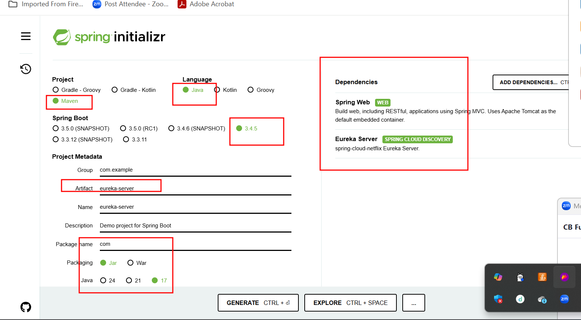

In application.properties file we need to add few configuration details.

**server.port=8761**

**eureka.client.register-with-eureka=false**

**eureka.client.fetch-registry=false**

in main class

@EnableEurekaServer

Run this project and verify eureka Server running on port number 8761

Creating first micro service project

**cab_fare_micro_service**

**starter**

**web starter**

**eureka client starter**

**jpa starter**

**my sql connector**

**dev tools**

we create rest controller with 2 end point

1. To store cab details
2. To find the fare of cab base upon source and destination.

**cab_book_micro_service**

**starter**

**web starter**

**eureka client starter**

**jpa starter**

**my sql connector**

**dev tools**

**thymeleaf starter**